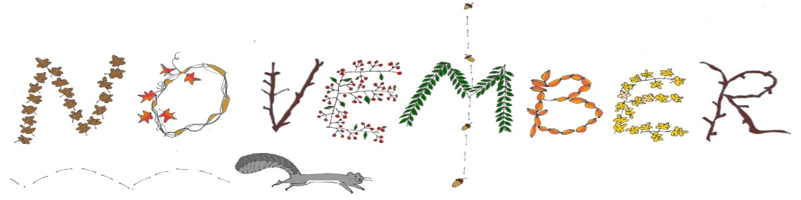
Sunday | Monday | Tuesday | Wednesday | Thursday | Friday | Saturday
 |  |  |  | 1 Look for Circles Day! | 2 | 3 Book Lover’s Day!
4 | 5 | 6 | 7 | 8 | 9 | 10  VETERANS ***DAY***
11 | 12 | 13 | 14  Friendship Feast  PS 1 & 2  Jr. PK  & PK | 15 | 16  World Peace Day! | 17
18 | 19  Universal Children’s Day | 20 | 21 | 22  Happy Thanksgiving! | 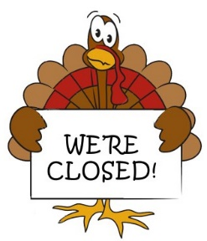  2 | 24
25 | 26 | 27  French Toast Day! | 28 | 29  Stay Home Because  You Are Well Day! | 30
-Pictures will be on Tuesday, Dec. 4th and Wednesday Dec. 5th starting @ 7am.
-See office poster for group designated days.
-Jr.PK & PK: Vision & Hearing screenings with be done here @ 9am Tuesday the 14th. See office with any questions.

